SCHOOL MANAGEMENT SYSTEM

Theme:
To manage a school’s records of student’s examination marks
Modules:
- Students
- Marks
- Exams
- Subjects
E-R DIAGRAM:
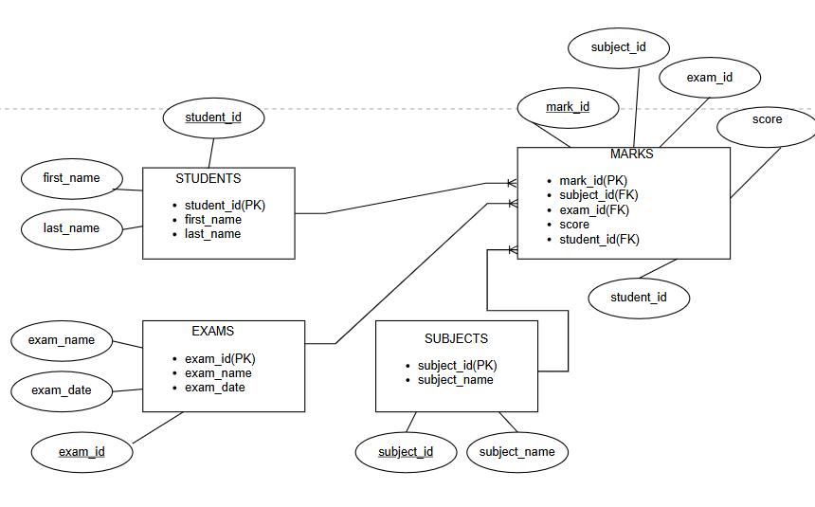
SAMPLE DATA:
1)Students Table:
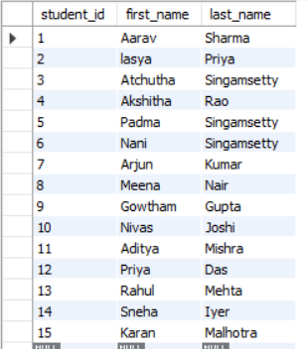

2)Subjects Table:
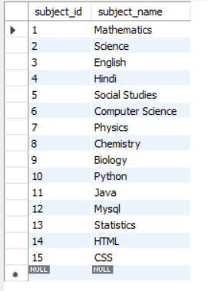

3)Exams Table:
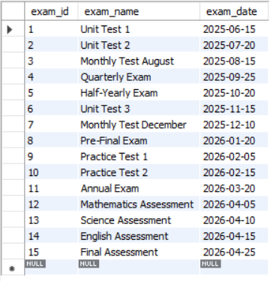
4)Marks Table:
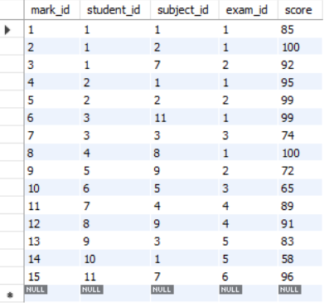

QUESTIONS:
- Retrieve all students: List the first name and last name of every student.
QUERY:
select first_name,last_name from student;
OUTPUT:
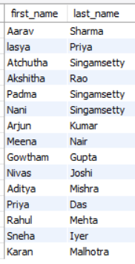

- Filter by Score: Find all entries in the Marks table where the score is greater than 80.
QUERY:
select * from marks
where score>80;
OUTPUT:
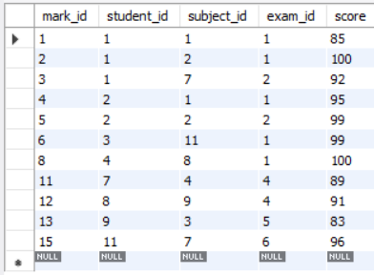

- Sort Data: List all exams sorted by their date, starting with the most recent.
QUERY:
select * from exams
order by exam_date desc;
OUTPUT:
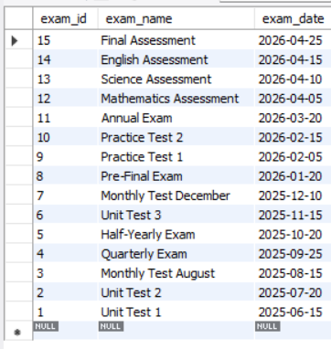

- Student Marks: List the First Name, Subject Name, and Score for every mark recorded.
QUERY:
select s.first_name,sb.subject_name ,m.score from marks m
join students s on m.student_id =s.student_id
join subjects sb
on m.subject_id =sb.subject_id;
OUTPUT:
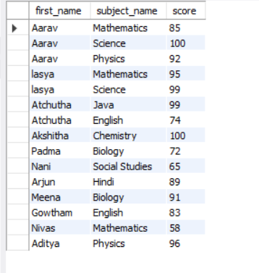

- Subject Averages: Calculate the average score for each subject. Display the Subject Name and the Average Score.
QUERY:
select sb.subject_name,avg(m.score) as average_score
from subjects sb
join marks m
on sb.subject_id=m.subject_id
group by sb.subject_id,sb.subject_name;
OUTPUT:
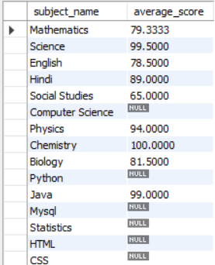
- Count Exams: How many marks have been recorded specifically for "Aarav Sharma"?
QUERY:
select count(m.score) from marks m
join students s
on s.student_id=m.student_id
where s.first_name="Aarav" and s.last_name="Sharma";
OUTPUT:
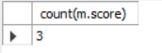

- Top Performer: Find the student (First Name, Last Name) who has the highest single score in any exam.
QUERY:
select s.first_name,s.last_name,m.score
from students s
join marks m
on s.student_id=m.student_id
where m.score =(select max(score)
from marks);
OUTPUT:
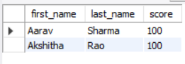
- Scores by Exam: Display the Exam Name and the total sum of scores for that exam, but only for exams where the total sum is greater than 250.
QUERY:
select e.exam_name,sum(m.score) as total_score
from exams e
join marks m
on e.exam_id =m.exam_id
group by e.exam_id,e.exam_name
having sum(m.score)>250;
OUTPUT:
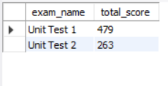
- Pass/Fail Label: Create a report showing the Student Name, Subject, Score, and a status column that says "Pass" if the score is 70 or above, and "Fail" if below.
QUERY:
select s.first_name ,s.last_name ,sb.subject_name,m.score,
case when m.score>= 70 then 'Pass' else 'Fail'
end as status
from marks m
join students s
on m.student_id=s.student_id
join subjects sb
on m.subject_id=sb.subject_id;
OUTPUT:
